Problem #3
Chapter 3
Sam Quinn
CS372
02/09/2016

Review Questions
R2
a)
One way that the message delivery system above could be implemented is very similar to the system that we use in the real world. The sender would first need to make sure that the message being sent meets the following requirements.
Sending:
- House address clearly marked on the outside of the envelope.
- The message inside clearly marked with the recipients name.
- Message put in the outgoing message queue for delivery.
With the requirements above the message would be picked up from the outgoing queue and the postman will instantly know where that envelope needs to be delivered, but will not know who the family member the message inside the envelope is meant to be delivered to. For the message to be delivered to the correct family member anyone form the house may open the letter see the family members unique name then pass the message to the final destination.
Receiving:
- Pick message up from the incoming queue
- Open the envelope and determine unique family member name
- Deliver the message to the family member
B)
No, the mail service would never have to open the envelope to deliver the message. The local family would have to open the envelope however to deliver it the the correct family member.

R4
UDP is great when you do not need every single bit of information or if you are constantly coming in and out of connection. One of my projects that I used UDP for was sending accelerometer and gyroscope data over wireless. UDP was preferred because the transmission rate was very fast and if I dropped a packet there was a new more updated one ready for me, the dropped packet was never a problem.
R9
Because we need to guarantee transmission with an RDT protocol the sequence numbers are used to check that each packet that has been sent has been received by the recipient. With the sequence numbers increasing both parties are able to deliver packets in order.
Problems
P1
With the use of socket there can be one or more separate sockets on each port. Each socket has a unique identifier that is used
a) A → S
A can really choose any port they choose but it must only go to the port 23 on S. For this question lets just assume that A chooses 4444.
Source: 4444 Destination: 23
b) B → S
B can also choose any port of their choosing but same as A the destination port for S has to be 23. For this question let B choose 5555.
Source: 5555 Destination: 23
c) S → A
Now that both the client and the server have determined their ports they must use the same port numbers through out the rest of the transmission.
Source: 23 Destination: 4444
d) S → B
The server must also send the data to the same port that B sent their message with.
Source: 23 Destination: 5555
P3

1 | 10 | 1 | 1 |  | 1 | 1
 | 0 | 1 | 0 | 1 | 0 | 0 | 1 | 1
 | 0 | 1 | 1 | 0 | 0 | 1 | 1 | 0
+ | 0 | 1 | 1 | 1 | 0 | 1 | 0 | 0
Wrap 1 around | 0 | 0 | 1 | 0 | 1 | 1 | 0 | 1
 | 0 | 0 | 1 | 0 | 1 | 1 | 1 | 0
Ones compliment | 1 | 1 | 0 | 1 | 0 | 0 | 0 | 1

The reason that UDP takes the 1's complement is in case any of the bit got “flipped” or corrupted somehow in transmission. When the checksum is complemented with the message sum it should return all 1's so if there are any zeros it would be easy for the program to detect this. If an odd number of bits get corrupt including 1 corrupt bit the checksum will detect it, but if there are 2 bit are corrupted in the same spot across two different words the error will go undetected.
P15
Based on the example below the Figure 3.17 the transmission rate is 1Gbps.

The window size for the utilization to be greater than %98 would have to be larger than 2450.98.
P17
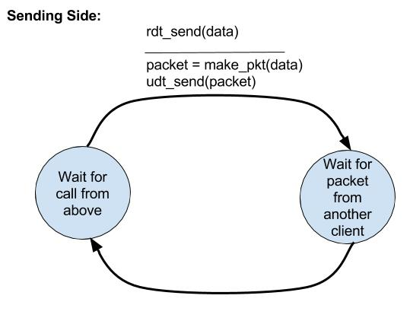
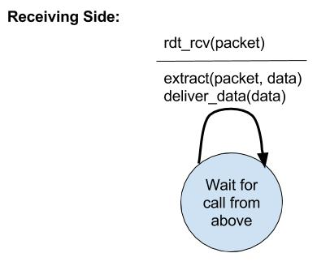
The serialization of the transmission is setup in the sending side of the FSM. After a packet is sent the send will not send another until it receives a message from the other client.

P24
a) - False, an ACK must be contained inside of a selective repeat protocol window.
b) - True, since ACKs can arrive out of order while the messages might not still be available.
c) - True, these are functionally equivalent because with a window size of one the sender and recipient will have to alternate.
d) - True, these are functionally equivalent because with a window size of one the sender and recipient will have to alternate.
P38 - Must the rate at which the sender is sending when the loss event occurred be approximately equal to cwnd segments per RTT?

P40
a) Slow start is occurring between 0-6 and 23-26
b) Congestion avoidance is taking place from 6-23
c) Since the 16th transmission does not reinitialize the slow start recovery this is probably a triple duplicate ACK.
d) The segment loss at 22 was a timeout since the slow start was initiated again.
e) The initial value of ssthresh at the first round is around 32-33.
f) On the 18th transmission round the ssthresh was around 24.
g) On the 24th transmission round the ssthresh is set to around 14-15 which is half of where the window size got to before loss.
h) By adding up all of the window sizes the 70th segment is sent on the 7th transmission round.
I) It would be half of the ssthresh set for g) which was 14.5 and if we round that up to 15 the new ssthresh would be half which would be 7.5 which rounded up to 8.
j) With TCP Reno the ssthresh would be 24 and the window size on the 19th transmission round would be 7.
k) There would be 7 packets sent between 17-22 if there were a time out on the 22nd
P43 The bottleneck on this particular example would be on the sender side. TCP congestion control will never be activated in this case since all data over the wire can be stored in the large enough receiving buffer. Because the sender can only buffer a fraction of the file the transmission rate from A to B would be limited by the average rate R. While the S TCP socket bps is greater than R.
P55
a) The server will send its UDP packet back to the Y address as listed on the UDP packet it has received. This could be used as a malicious flooding attack where the address Y would be the victim, but since the victim Y will not be expecting those UDP packets they will inherently be discarded.
b) Even though the server chose a random initial sequence number that is stored in the TCP packet that can be captured over the wire. If an adversary were to spoof the source IP and increment the sequence number correctly the adversary X could successfully spoof Y without the server ever knowing.

